Design Document

Problem and Need Statement
Currently, there are a few products that can stream audio from a Bluetooth enabled device to any speaker or audio system with a 3.5mm auxiliary jack. However, most of these solutions are quite expensive, ranging anywhere from 40 to 70 dollars for the conversion module. The goal of our project is to build an alternative to the current competition at a cheaper price with similar product specifications and quality.

System Requirements

Functional Requirements
- Supports 16 bit audio
- Signal transformation
- PCB Design
- Data transfer
- Bluetooth 3.0/4.0 support
- Power supply(battery)
- Output analog audio signal

Non-functional Requirements
- Exterior design

Functional Decomposition

Overall Function
The goal of this project is to create a cost-effective universal Bluetooth to 3.5mm signal converter that would allow users to stream audio from a Bluetooth enabled device to any standard speaker set that has a 3.5mm audio connection.

Subfunctions
- PCB: two-layer, easily to build the circuit and decrease the cost.
- Power supply: inside battery, charge by USB connector
- Data transfer: Use User datagram protocol
- Connection: transfer data from device to controller by Bluetooth transceiver integrated circuit.
- Output analog audio signal: the output goes through the buffer circuit.
- 16 bit audio(@128 kB/s): between Bluetooth integrated circuit and DAC

System analysis

Identify how each subfunction processes the input in order to produce the output
The controller received the data by bluetooth 3.0 as input (the data transferred from phone to the controller by using user datagram protocol). This input received by bluetooth transceiver integrated circuit. And then, this input goes through the ASIC, buffer circuit and the Audio jacks to be an output.

Relate requirements to overall function, and subfunctions
Device transfer the data to the BT IC by UDP,The BT integrated circuit will send confirmation data back to Device and send audio(16 bit audio) to ASIC(involved DAC), and then processes serial stream into 16 bit voltage values, sends voltage values to DAC. And the output analog audio signal will goes through the Buffer circuit(involved Amplifier) and audio Jacks, and then goes to stereo. The exterior design is important as well, because we are looking for a cost-effective thing, so that we have to consider the exterior design.

Detailed Design

Input/Output Specification
The input to the overall system is an audio feed from a Bluetooth enabled device (as well as a DC voltage from a power supply and/or battery). The output of the system is a stereo analog audio signal, to be received by a stereo or desk speaker system.
The Bluetooth signal will be received by an RF transceiver-on-a-chip, and the information received will be sent, through a serial connection, to an Application Specific Integrated Circuit (ASIC) optimized for audio electronic devices. The Bluetooth chip will need to communicate with the device it is pairing with in order to carry out the action of pairing before audio may be transmitted from the device to the system.
The ASIC will be required to process the incoming serial stream from the Bluetooth Transceiver IC and then provide a 16 bit analog stereo audio output (at line levels), which will then be output to buffer circuits. The buffer circuits will be constructed using a first order low-pass filter (to smooth out the sinusoidal components that create “steps” in the DAC produced analog audio signals) and then an operational amplifier (in a unity gain configuration to allow current to be drawn from outside the ASIC for the output signal while maintain the transient voltage output of the DAC).
The outputs of the buffer circuits will then be sent through both a 3.5mm headphone jack and RCA audio jacks, wired in parallel.
The whole system will have to be powered by a power supply of some sort. This is to be accomplished by at least using a DC source from a power supply. The device is to have a way to connect a power supply directly to the circuit, and possibly have the option of battery power. Whatever is chosen for the final power supply option must have enough voltage to allow for a full voltage swing in the buffer unity-gain amps as well as operational voltages of the ICs used in the system. Also, it will have to be reasonable to include in the “distribution” version of the final product while keeping the final product to a reasonable manufacturing cost.
The Bluetooth chip will be required to support Bluetooth Core Specification 3.0 or better in order to allow enough data to be reliably transmitted to receive a 128kBit/s audio signal. Core Specification 4.0 can allow for low power features but will increase the variable costs associated with the Bluetooth IC.
There is not a specified amount at this time for the cost of any of these components. However, there will be three costs to keep to a minimum of each component. The first two are the evaluation board/materials and single unit purchase costs that will affect the drain on the total budget for this project. The third is the cost per part when bought on 1000 piece reels or other bulk format, so that the mass produced final product is a lower cost alternative to competing products already on the market.

User Interface
The user interface will have to allow the user to turn the device on and off (a physical switch will suffice) along with “POWER” and “CONNECTION” indicator LEDs to allow the user to understand if the systems

Test Plan

Test Environments
There will be a few different test environments. Our first task will be to test the code once we are fully done writing it. This will be done in Texas Instruments’ Integrated Development Environments called Code Compressor Studio. For this part of the testing phase, our task will simply be to test code reliability, overall efficiency, and code size. Our goal for the testing to should be to create firmware code that is smaller than 64kb since that the flash memory size of the controller. We expect our actual code size to range between 12kb to 48kb depending on features added and potential complications.
Our second test environment would be simple circuit analysis once we have all the components on a PCB. The goal for this portion of the testing would be make sure that all of the components are reliably performing. This phase of testing would include simple circuit analysis work. Things such as checking voltages across any resistors that we plan on using, checking voltage levels across any connection lines between our two main components, and making sure our power components (battery, AC/DC converter) are providing the right voltages and current levels necessary for our overall system to function.
The third test environment would be using specifically processed audio files to check overall audio quality that the system provides. This will be the final phase of the testing. We will use this test environment to check final product quality and make any tweaks that may be necessary.

Test Design
Firmware/Code testing
- DRAM/Register Stress test: test will continually set bits to high and set them back to low. It will be testing whether or not our DRAM is properly functioning and whether or not our registers are reacting the way our code designed them to.
- Boot-Up test: test will check registers and code markers during the bootup process and store them in the DRAM so that we can read the results once bootup is complete. Purpose of this test would be to make sure the proper boot up sequence took place. Test would analyze whether or not proper clock speeds are being set, whether or not the PLLs are being set properly, and whether or not the DRAM is being cleaned at the end of bootup.
- Code Efficiency Test: Test will entail many small factors. We will perform a rough variable map of the code to make sure that all of our variables are efficiently being utilized and stored. We will also calculate Big-O runtimes for portions of the code to get an idea of the execution speed. Lastly, we will have a different member of the group proofread each other’s code to make sure proper design principles are being followed.
Hardware Testing
- Voltage/Current/Power Test: Simply check voltages across resistors, capacitors, and wires from one component to another. Goal is to check component reliability and potentially replace any faulty components.
- Signal Integrity Testing: We would need to test and verify that all of the signals we generate in the components are meeting our set standards and that they are both clean and reliable. We would simply trace certain signals from the hardware to an oscilloscope and check for any breakdowns over time and during stress situations such as high Bluetooth data transmission phases, or when there is more power draw than usual.
Product Quality Testing
- Audio Quality Test: We will perform this test in two ways. First way will be to simply play actual music and check audio quality in various speaker setups. The second step would be to check audio quality by playing modified sound files that check for frequency ranges in sound and different notes in music.

Prototyping
Testing subsystems of the full system will be important to make sure that the outputs of each isolated part of the system are correct. Doing so will assist in locating bugs and poor-performance issues, as well as making it easier to figure out modular designs in order to make the construction and evaluation of the first full prototype proceed smoother.
Evaluation of the full system will be carried out by evaluating the transmission of audio files containing sinusoids of different frequencies in order to gauge the distortion on the device outputs.
Modeling for the analog subsystems will require AC, DC, and Transient considerations. Digital portions of the system will require an understanding of the IC’s own libraries, clocking speeds, etc.

Other Project Specific Components

Mechanical Design (CAD)
We will design an enclosure for the printed circuit board (PCB). It will be done strictly for aesthetic purposes. This will be an extra feature for the project in case we have time to add elements.

Electronic Circuit Design
Below is a simple block diagram for the design of the module. Once we begin our design work, we will design a more detailed circuit.
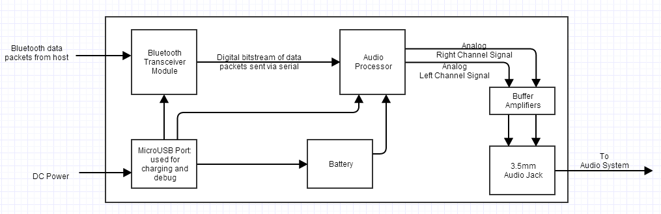
Figure 1: Circuit block diagram of the system

Printed Circuit Board Design
We plan on designing our PCB next semester. We may choose to go with a pre-fabricated board if we find one that fits our needs and is more cost effective.

Software Design
No software design is necessary for this project. The software components for the project will already be pre-designed by the makers of the host system (either a smartphone, laptop, or other Bluetooth enabled device), so we will not need to. For our part, we simply need our hardware to meet Bluetooth compliance standards so that the host devices can detect our device.

